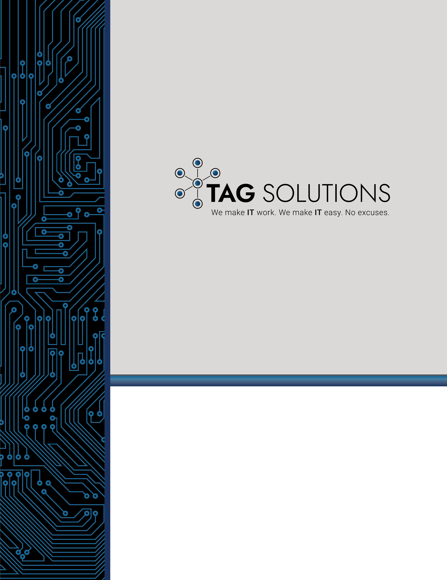

Cloud vs. On-Premise Phone Systems

Provided by TAG Solutions

Cloud-based phone systems offer a number of advantages over on-premise systems. They are typically more affordable (though not necessarily), easier to set up and manage, and offer more features and flexibility. However, there are also some disadvantages to using a cloud-based system, such as potential security risks and a loss of control over the system.

Cloud-based systems are typically a good choice for small businesses or businesses that don't have the IT infrastructure to support an on-premise system. On-premise systems are generally a better choice for larger businesses that need more control over their phone system and are willing to invest in the necessary hardware and infrastructure.

For a company that offers a hybrid workplace, a cloud-based system may be ideal. This type of system can connect employees who are working in different locations and allow them to communicate as if they were in the same office.

Cloud-based systems are also a good choice for businesses that have employees who travel frequently, since they can easily connect to the system from any location with an internet connection.

If you're considering a cloud-based phone system for your business, it's important to weigh the pros and cons to decide if it's the right choice for you.

Which type of phone system is more secure? There is no definitive answer to this question. On-premise systems may be more secure because they are not connected to the internet and therefore are less vulnerable to hacking. However, cloud-based systems can also be designed to be highly secure, with multiple layers of security in place.

It's important to consider your specific security needs when deciding which type of phone system to choose. If security is a major concern, you may want to consult with an IT expert to find the best solution for your business.

Do you need to buy any new equipment? If you choose a cloud-based system, you will not need to invest in any new hardware. You will, however, need to have high-speed internet in order to use the system. On-premise systems require you to purchase and install PBX hardware, which can be expensive. You will also need to have someone on staff or a dedicated MSP you trust who is familiar with how to maintain and troubleshoot the system.

What are the long-term costs? Cloud-based phone systems typically have lower upfront costs than on-premise systems. However, you will need to pay a monthly fee to use the system, and you may also incur additional charges for features such as voicemail and call forwarding. On-premise systems generally have higher upfront costs, but there is no monthly fee.

Why not just use cell phones instead of a cloud-based business phone system? You could use cell phones for your business, but there are some advantages to using a cloud-based system instead.

With a cloud-based system, you can have a professional voicemail greeting and menu, which can give your business a more polished and professional appearance. You can also add features such as call forwarding and conference calling, which can be useful for business communications.

Another advantage of using a cloud-based system is that it can be easily scaled up or down to meet the changing needs of your business. If you experience a sudden increase in call volume, for example, you can quickly add more lines to your system without having to purchase new hardware.

Are you wondering if you should bother replacing your phone system now? If it's worked fine for 15 to 20 years, why not just wait for it to fail? While this might seem logical, chances are good your current system lacks efficiency and security that would benefit your business. Lost or dropped calls mean lost revenue and frustrated customers. Plus, an unexpected failure can mean significant hardship at the time the system goes down. Being prepared and proactive is always better.

Can my company just use Zoom or a similar web conferencing option instead of a new phone system? While you can use web conferencing for some business communications, it's not a replacement for a business phone system. A business phone system is designed specifically for making and receiving calls, while web conferencing is better suited for hosting meetings or presentations.

A business phone system also gives you the ability to have multiple lines and extensions, so customers can reach the person they need to talk to without being put on hold.

Finally, a business phone system can help to project a professional image for your company, while using a personal cell phone or web conferencing solution may give the impression that your business is small or unprofessional.

If you're still not sure which type of phone system is right for your business, contact us and we'll be happy to help you decide.

